**Class Overview:**

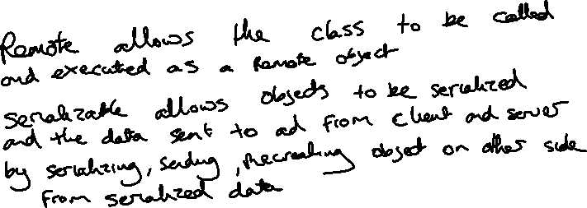

List of changes that have to be made to this RMI Implementation for it to work as a RPC Version



* A Protocol buffer file will have to be made all of the available services of the server and a copy should be placed in the clients src folder
* The QueryServer will need the methods re-written to ones using the Protocol Buffer Library versions
* Stub files for the server classes will have to be generated
* Instead of making an Queryserver object available to the RMIRegistry, the QueryServer will have to create an instance of the GRPC Server and execute that.
* The client will have to connect to the GRPC Server in the main method instead of finding the RMI and will have to request a service from the server